Acquisitions and Mergers of Google incorporation
Student’s Name
Institution

Contents
Part A: 3
Introduction 3
Strengths, weaknesses, opportunities, and threats of Alphabet Inc. 3
Merging Google incorporation through horizontal acquisition 5
The synergy of Google incorporation with its mergers and acquisitions 5
Valuation of Facebook incorporation 6
Free Cash Flow 6
Cost of Capital 7
Part B: 12
Importance of effective teamwork and coordination of activities in future studies and professional practice. 12

Part A:

Introduction
As an employee of Cowen investment group, we assessed various opportunities presented by mergers and Acquisitions as well as ways of making key investment decisions. This was an initiative of Apple incorporation to assist them to decide on the best investment platforms. Assessment of marketing. We analyzed the strategies employed by Google incorporation to achieve great market presence and position.

Strengths, weaknesses, opportunities, and threats of Alphabet Inc.
Alphabet incorporation which comprises many businesses such as Google, Access, Calico, CapitalG, GV, Nest, Verily, Waymo, and X has many several strengths that they capitalize on to grow their businesses (Renneboog, Szilagyi & Vansteenkiste, 2017). In particular, Google incorporation that has invested in areas such as Search, Android, Maps, Chrome, YouTube, Google Play, and Gmail that have billions of users all over the world, has invested on various strategies to ensure that their businesses expand extensively. They have capitalized on performance and brand advertising as well as in the area of artificial intelligence. Their major strength is on the artificial intelligence platform that uses technologies such as voice recognition systems (Renneboog, Szilagyi & Vansteenkiste, 2017). In addition, Google incorporation dominates the online advertising platform, web searches, dominance in Android mobile operating systems. All these are possible since Google has a large base of information that they obtain from Google Search, Google Analytics, YouTube, Android OS, and Chrome. It also has excellent acquisition abilities (Renneboog, Szilagyi & Vansteenkiste, 2017). For example, it acquired over 117 companies from 2012 to 2017 including Alphabet, Microsoft, Facebook, and Apple. (Castellaneta & Conti, 2017). By buying companies, Google incorporation takes the leading edge in new technologies that come with the employees of these companies.
However, Google incorporation whom the source of revenue come from advertising has a weakness that emanates from the fluctuations of demands from adverts (Castellaneta & Conti, 2017). With the emergence of advertising platforms such as Facebook it is noted that the number of click per advert reduced drastically as compared to that of Facebook. Again, even though Google products dominate most markets, they have not vividly defined their market position making them be vulnerable to their competitors such as Facebook (Renneboog, Szilagyi & Vansteenkiste, 2017). Also, Alphabet incorporation spends a lot in operations that can put it at risk of being by-passed by its competitors. Another major weakness the company faces is the high turnover rate of its employees that comprise of its top executives. This is a serious phenomenon that can make it lose a competitive advantage over companies like Facebook (Renneboog, Szilagyi & Vansteenkiste, 2017). It is estimated that a majority of the employees take a maximum of 2 years then shift to other competing companies.
On the positive side, Google has various opportunities that put it ahead of its competitors. For instance, it has expressed interest and invested in an android technology known as Android M (6.0) that has given it a competitive advantage over Facebook’s mobile advance. In addition, it has extensively invested introduced products such as Android for Work and Chrome for Work in the enterprise market to effectively compete with companies such as Microsoft and Apple. It has invested in Google Play music with the aim of getting more profits from adverts and subscriptions. On the darker side, Google faces several threats from its major rivals such as Amazon, Facebook, and Apple. Firstly, Facebook now boasts of many subscribers than Google. With these great numbers, companies wishing to advertise their products will obviously approach Facebook first to get their adverts too many users.

Merging Google incorporation through horizontal acquisition
Google incorporation should be merged with other companies such as Facebook, Amazon and Apple incorporations as they offer similar services and products. Through acquiring these companies, competition can greatly reduce. For instance, since Facebook has close to one billion users, Google incorporation will benefit from such an acquisition or merger because all adverts meant for Facebook will be channeled Google. This will generate more revenues since the companies advertising through Google as a result of the acquisitions will greatly increase. Another great benefit that Google incorporation is likely to benefit from is the economics of scale and increasing the bargaining power with suppliers. Horizontal mergers with companies like Facebook, Amazon, and Apple is likely to give Google an upper hand in the management of the company. This is because horizontal mergers only join companies in the same business and for that matter, Google’s top management cannot have management problems since the mergers were also dealing in the same products. Just like Facebook is an online advertising platform, so is Google incorporation.

The synergy of Google incorporation with its mergers and acquisitions
Through the analysis of the mission, vision, and strategies of various companies it was recommended that Google incorporation could merge with Facebook, Amazon, and Apple since they shared similar development strategies and growth objectives. The three companies share the vision of ensuring that their customer gets the best experience with their products and services. Just the way Google’s main vision is organizing the world’s information and making it accessible to people, Facebook sees the world as a global village where can have the power build the community together (McKeon, & Solomon, 2017). In addition, Amazon has the vision of ensuring that their customers get the best experience through its software and hardware services that is also shared by Apple incorporation. Google merging with a company like Facebook and Amazon will give it a monopoly in terms of online advertising as well provision of other products and services (McKeon, & Solomon, 2017). Since Amazon is a leader in online marketing worldwide, it can gain greatly in the selling of products and reaching out to many customers. In addition, the company has post-integration potential advantages since companies such as Facebook and Amazon have services and products that are in line with Google’s vision. Again, Amazon is a leader in marketing products all over the globe and thus can give Google incorporation an advantage in being a monopoly.

Valuation of Facebook incorporation
Using the free cash flow methodology, Facebook has shown great growth rates in the last 5 years with an exception of 2015 when it experienced a drastic drop.

Free Cash Flow
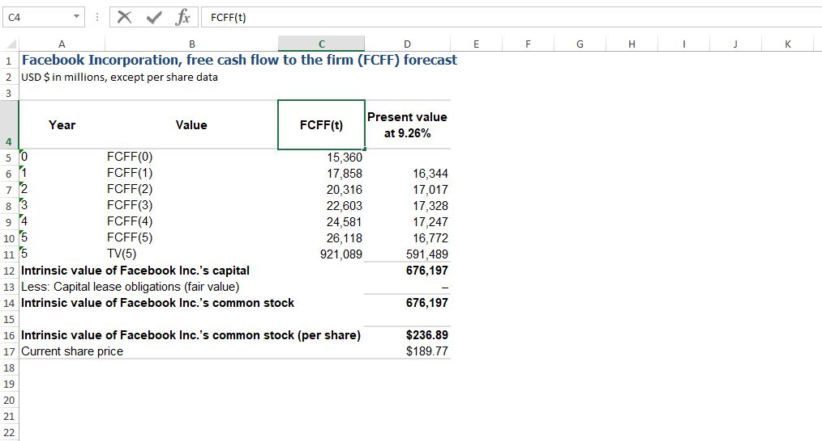

Cost of Capital
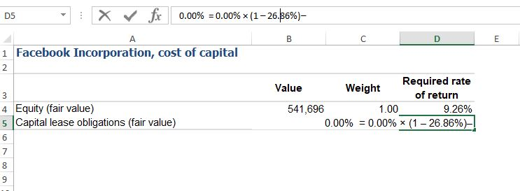
$$USD \$ in millions$$
$$Equity \left(fair value\right): = No. shares of common stock outstanding × Current share price$$
$$= 2,854,488,736 × \$189.77 = \$541,696,327,430.72$$
$$Capital lease obligations \left(fair value\right):$$
$$The required rate of return on equity is estimated by using Capital Pricing Model\left(CAPM\right):$$
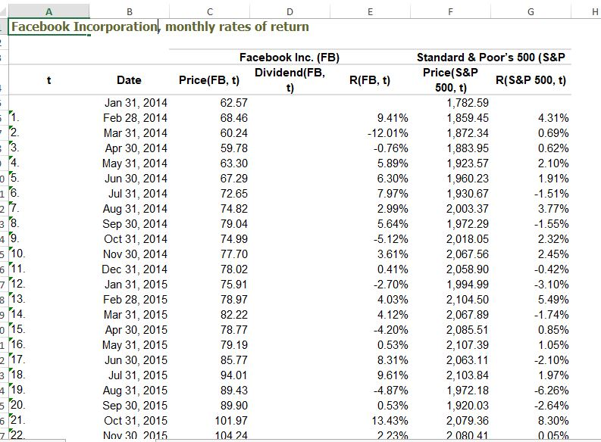

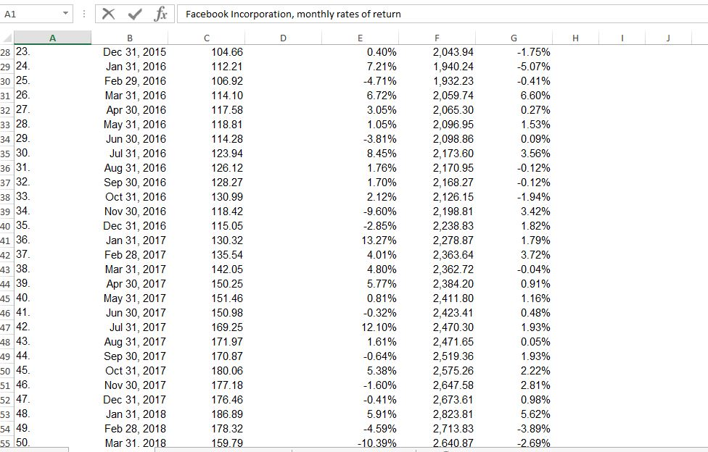
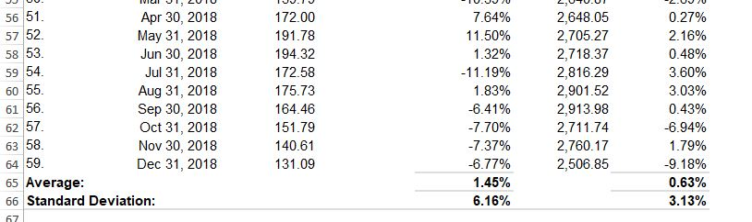
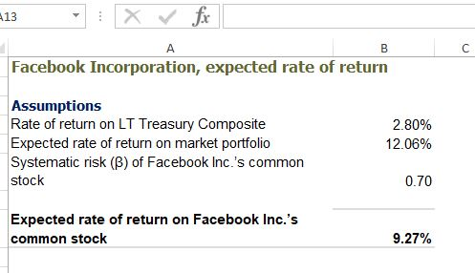
$$Therefore, Estimated \left(average\right)effective income tax rate for the 5 years:$$
$$= (12.80\% + 22.60\% + 18.40\% + 40.40\% + 40.10\%) ÷ 5 = 26.86\%$$
Therefore;$WACC=\frac{E}{V}×Re+\frac{D}{V}×Rd×\left(1-Tc\right)$
Where:
Re = total cost of equity
Rd = total cost of debt
E = market value total equity
D = market value of total debt
V = total market value of the company’s combined debt and equity or E + D
E/V = equity portion of total financing

D/V = debt portion of total financing
Tc = income tax rate
Therefore:
As at March.2019, Facebook Incorporation latest two-year average Current Portion of Long Term Debt was $665.5 Million and its latest two-year average Long-Term Debt & Capital Lease Obligation was $0 Million .The total Book Value of Debt (D) is $665.5 Mil.
$$a) weight of equity = E / (E + D) = 541039.795 / (541039.795 + 665.5) = 0.9988$$
$b) weight of debt = D / (E + D) = 665.5 ÷(541039.795\} + 665.5)$
$$= 0.0012$$
Also, the Cost of Equity = Risk-Free Rate of Return + Beta of Asset ×(Expected Return of the Market - Risk-Free Rate of Return).Again, the current risk-free rate of Facebook is 2.51000000% and beta 1.30 from the data obtained in the Facebook’s 10k report. Therefore:
$c)Cost of Equity = 2.51000000\% + 1.30 × 6\% = 10.31\%$
In addition, as at December 2018, Facebook’s interest expense had reached $9 Mil. Its total Book Value of Debt (D) is $665.5 Mil.
Cost of Debt = (9 $÷$ 665.5)100% = 1.3524%.
Also, the latest Two-year Average Tax Rate is 17.72%.
Therefore, Facebook’s WACC
$$= 0.9988 × 10.31\% + 0.0012 × 1.3524\% × (1 - 17.72\%)$$
$$=10.3\%$$
Present value and terminal value of Facebook:
Facebook free cash flow for the quarter ending March 31, 2019 was 5,471.00, a year-over-year. Again, its annual free cash flow for 2018 was $15.359B,a 12.15% that indicated a drop decline from 2017. In 2017, it got an annual free cash flow of $17.483B, a 50.49% increase from 2016.Also, its annual free cash flow for 2016 was $11.617B, a 48.99% increase from 2015 as shown by the data in the 10k report.
Growth Rate
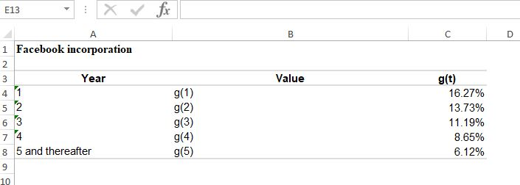
Calculations

$$where:$$
$$g1 is implied by PRAT model$$
$$g5 is implied by single-stage model$$
$$g2, g3 and g4 are calculated using linear interpoltion between g1 and g5$$

$$Calculations$$

$$g2 = g1 + (g5 – g1) × (2 – 1) ÷ (5 – 1)$$
$$= 16.27\% + (6.12\% – 16.27\%) × (2 – 1) ÷ (5 – 1) = 13.73\%$$

$$g3 = g1 + (g5 – g1) × (3 – 1) ÷ (5 – 1)$$
$$= 16.27\% + (6.12\% – 16.27\%) × (3 – 1) ÷ (5 – 1) = 11.19\%$$

$$g4 = g1 + (g5 – g1) × (4 – 1) ÷ (5 – 1)$$
$$= 16.27\% + (6.12\% – 16.27\%) × (4 – 1) ÷ (5 – 1) = 8.65\%$$

Assumptions and justification of Facebook Growth Rate
Various assumptions have been made in the calculation of Facebooks growth rate. For instance, the growth rate is assumed to be uniform even though through the calculations from year 1 to year 5, a steady decline in growth rate is observed. There is a sharp decline from 16.27% to 13.73% in year 1 and year 2 respectively. This trend remains the same up to year 5 In addition, Facebook’s revenue in terms of quarter and year has been varying since the year 2016, for example the first quarterly growth in revenue was 51.91% in 2016, 49.24% in 2017, 48.98% in 2018 and 26% in 2019.It is noted that there was decline of 2.67% between 2016 and 2017 and a decline of 0.96%.In addition, there was a decline of 22.98%(“Facebook Inc.”, n.d).This marked the greatest decline in the growth rate in Facebook revenue in comparison with other previous years. In the calculations, it is assumed that growth rate declined uniformly in each financial year for Facebook. The growth rate is assumed to be uniform to enable consistent cash flow to help in the balancing of free cash flow to the firm.

Part B:

Importance of effective teamwork and coordination of activities in future studies and professional practice.
Effective teamwork and coordination of activities are very significant for completion of assignment given to a group. Teamwork makes work to be accomplished at a faster rate as it is done as a team instead of only one individual, facilitates relations amongst team members, and promotes a healthy competition amongst team members, learning opportunities amongst members and ensuring that work is not unattended. Firstly, I learnt that teamwork and coordination of activities made completion of assignments faster (Grover, Porter & Morphet, 2017). This was possible since each and every member was allocated questions to do research on and later submit the results. The solutions were then presented to the team leader for approval. Secondly, I learnt that teamwork was also important as it promoted relations among team members. This is because group members shared so many things thus improving our interpersonal relationship skills. Development of interpersonal skills was done through effective listening, speaking and writing (Grover, Porter & Morphet, 2017). For instance if I wished to get some information from I learnt to use courteous words such as “please” and “excuse me” when requesting for some assistant from a group member. Courtesy on my part endeared me to many members as most saw me as an approachable and being ready to come to their rescue at any given time.
Through effective teamwork and communication, members developed a positive competitive spirit beneficial for the group. I learnt that a positive competitive spirit was essential in helping our group to accomplish its assignment early (Bender, 2016). For instance, we agreed as group that each member would have to beat a set deadline and the first person to complete the task assigned to them would be rewarded. Through that most of the members accomplished their tasks earlier than expected as everybody to the first and also get the reward.
In conclusion, I realized that for effective teamwork and coordination of activities in group work and professional practice members need to properly utilize communication skills such as listening, speaking and writing. Through listening to each other’s contribution, we were to accomplish the assignment at the stipulated time. I learned that for one to be an effective leader, they have to inculcate great listening skills. This is because a great listener is also a great thinker. When one gives a speaker a listening ear, the speaker feels valued and will likely give the best to the audience (Grover, Porter & Morphet, 2017). I also learnt that a good speaker should employ the use of facial expressions, gestures and body movements. The use of facial expressions give the listener an easy time in comprehending what the speaker says. For instance each member ensured that they employed the best ways to make sure that all participants in the groups vividly understand the concepts that they put across (Bender, 2016). In addition, writing is also an important skill that I learnt is useful in group work or teamwork. I learnt that for retention of content and for the purpose of future reference for the group, it was significant that members note down the points.

References
Bender, M. (2016). Clinical nurse leader integration into practice: developing theory to guide best practice. Journal of Professional Nursing, 32(1), 32-40.
Castellaneta, F., & Conti, R. (2017). How does acquisition experience create value? Evidence from a regulatory change affecting the information environment. European Management Journal, 35(1), 60-68.: https://www.strategicmanagementinsight.com/swot-analyses/google-swot-analysis.html
D., McKeon, S. B., & Solomon, S. D. (2017). Do takeover laws matter? Evidence from five decades of hostile takeovers. Journal of Financial Economics, 124(3), 464-485. Journal, 35(1), 60-68.: https://www.stock-analysis-on.net/NASDAQ/Company/Facebook-Inc/DCF/Present-Value-of-FCFF
Grover, E., Porter, J. E., & Morphet, J. (2017). An exploration of emergency nurses’ perceptions, attitudes and experience of teamwork in the emergency department. Australasian Emergency Nursing Journal, 20(2), 92-97.
Renneboog, L., Szilagyi, P. G., & Vansteenkiste, C. (2017). Creditor rights, claims enforcement, and bond performance in mergers and acquisitions. Journal of International Business Studies, 48(2), 174-194.: https://www.theguardian.com/technology/2015/aug/11/google-alphabet-why-change-restructuring-what-it-means
Facebook Inc. (n.d).CSIMarket.com.Retrieved from https://csimarket.com/stocks/single_growth_rates.php?code=FB&rev

